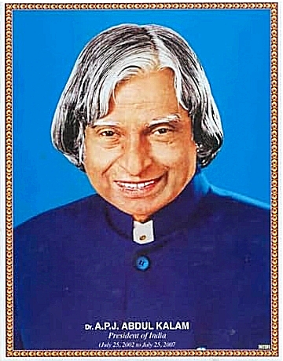 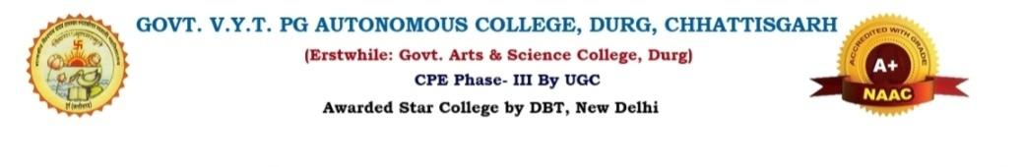“92nd Birth Anniversary Celebration Of

DR.A.P.J ABDUL KALAM”

* ***Kalam nahin , Kamal hai.***

***The Physics Society of Govt.V.Y.T.PG. Autonomous College Durg, Chhattisgarh celebrated the 92nd birth anniversary of DR.A.P.J. ABDUL KALAM on 19 October,2024(Saturday).***

***On this occasion, HOD Dr.Jagjeet Kaur Saluja, Dr. Rama Shankar Singh, Dr.Anita Shukla, Dr.Siteshwari Chandrakar, Dr.Abhishek Kumar Misra, Dr.Kusumanjali Deshmukh were present and Dr. Durga Verma was present too. In this event,17 students from M.Sc. 1st sem. and 18 students from M.Sc. 3rd semester attended the programme.***

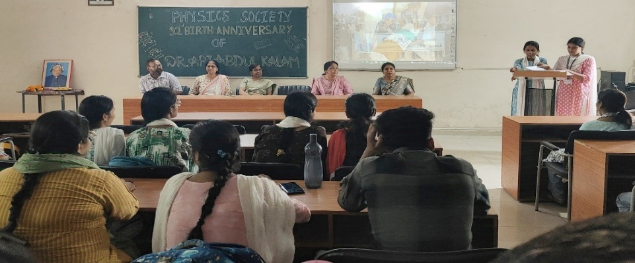

***The programme began by garlanding the portrait of Dr. A.P.J. ABDUL KALAM followed by lightening of lamp. HOD Dr.Jagjeet Kaur Saluja explained us that it is a day to remember his contributions technology and to inspire future generation and A.P.J. Abdul Kalam, India’s 11th president, was a trailblazing aerospace scientist and statesman who left an indelible mark on the country’s history.***

***• HOD Dr.jagjeet Kaur Saluja explaining the contribution of -***

***Dr. A.P.J. ABDUL KALAM***

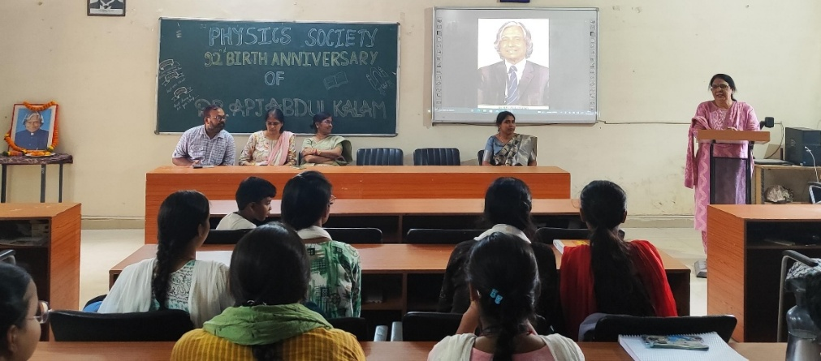 ***After Vandana from MSc 3rd semester gave a wonderful speech described Kalam’s introduction and journey. Then, Namrata from MSc 1st semester recited a poem and her poem captivated everyone. Then Upasana from MSc 1st semester give speech and described his great personality and struggle journey. After that, Aasha from MSc 3rd semester give her beautiful poem.***

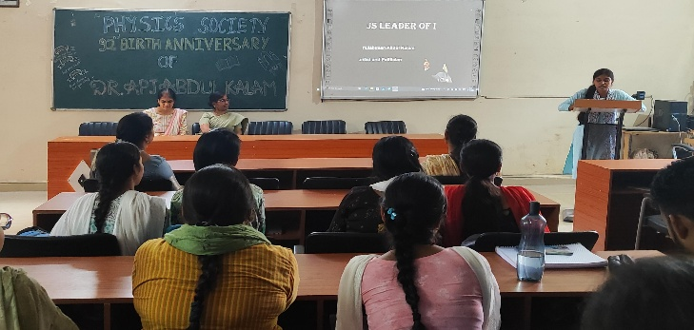 ***The programme was anchored by Namo Sen from M.Sc. 3rd semester and Gunjan Sahu from M.Sc. 1st semester. At the end of the programme, the vote of thanks was expressed by Indramohan from M.Sc. 3rd semester.***

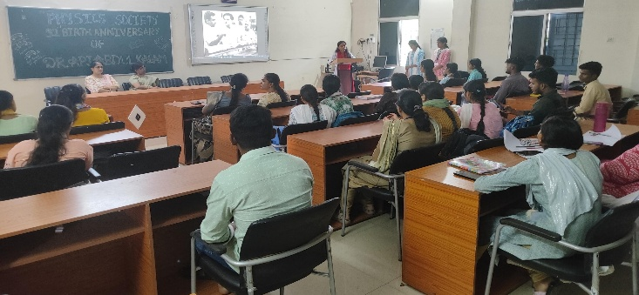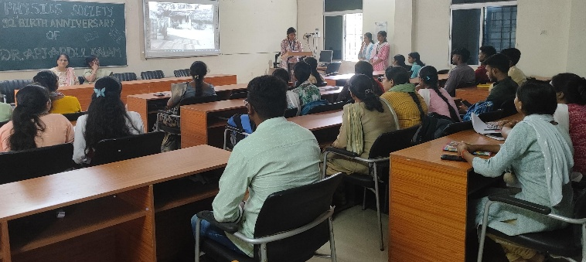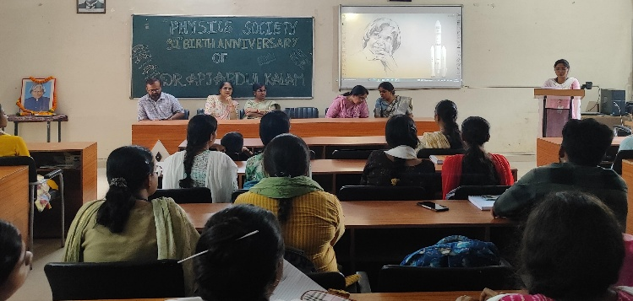***Vandana Sahu (MSc 3rd sem)-Speech. Namrata (MSc 1st sem ) - poem***

***Upasana (MSc 1st sem) – speech Aasha (MSc 3rd sem) - poem***